CoPYlot User Manual

1. Starting CoPYlot
1. Download the Application
Download CoPYlot (or the DataViewer) from the official website:
https://proteomics-data.com/downloads/

2. Unzip the Executable (if applicable)
If downloaded file is compressed (e.g. .zip), extract it before proceeding.

3. Launch the Application
Double-click the executable, or
Right-click the file and select Open.

4. First-Time Security Warning
On first launch, your operating system may display a security warning.
Select the options indicated within the warning dialog to proceed and allow the application to run.
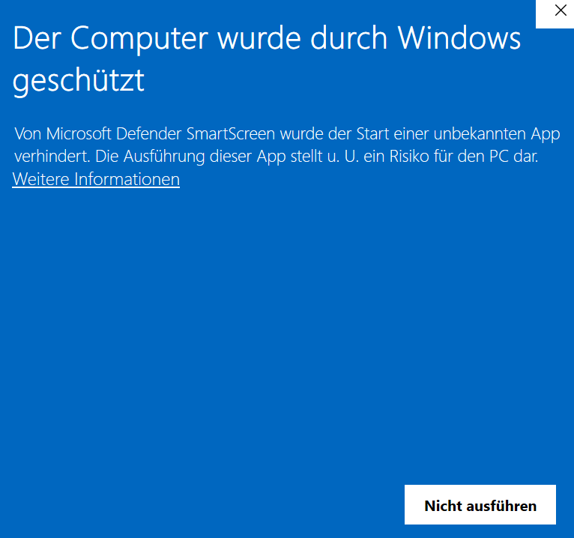
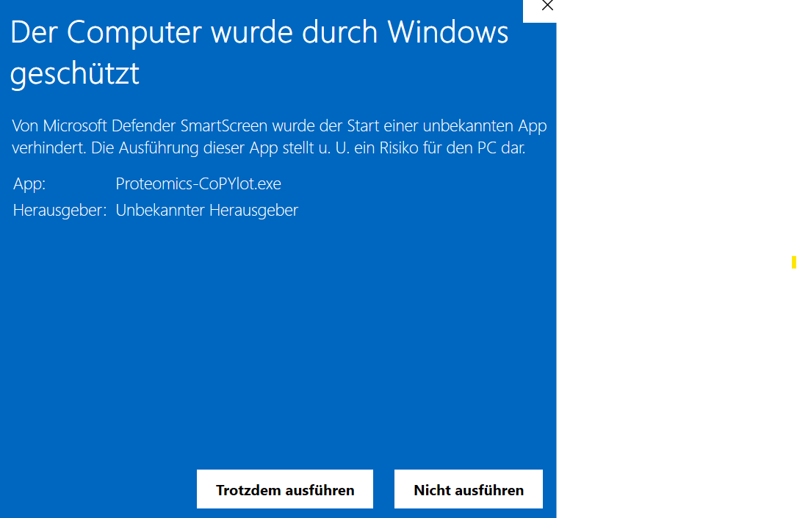
5. Accessing the Application Interface
CoPYlot or the DataViewer should automatically open in a new tab in your default web browser.
If it does not open automatically, navigate to:
http://localhost:8501/

2. Closing CoPYlot
1. Open the application’s sidebar.
2. Click the Quit App button.
3. The program will freeze after clicking Quit App. You may now safely close the browser tab.

